Edureka Case Study (Jenkins)

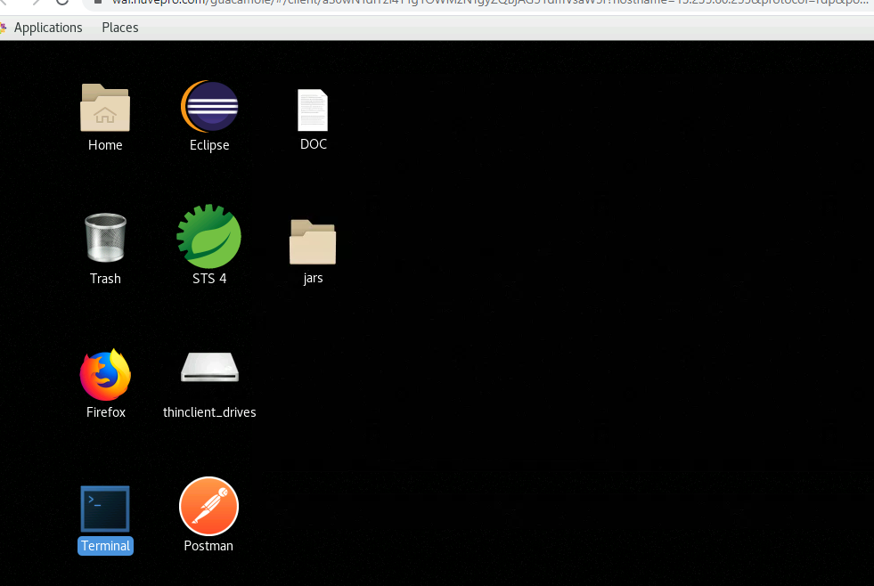

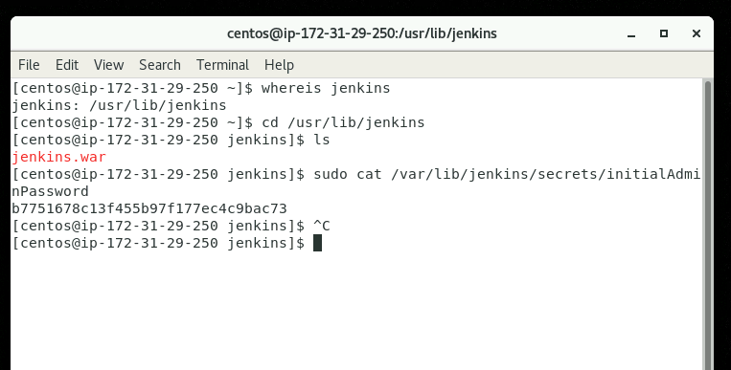

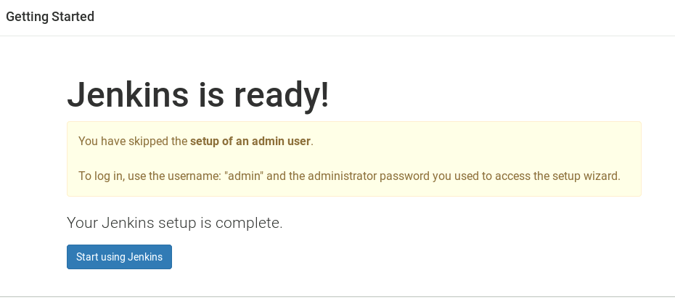

1.Create a Jenkins “Freestyle Project” and name the project.

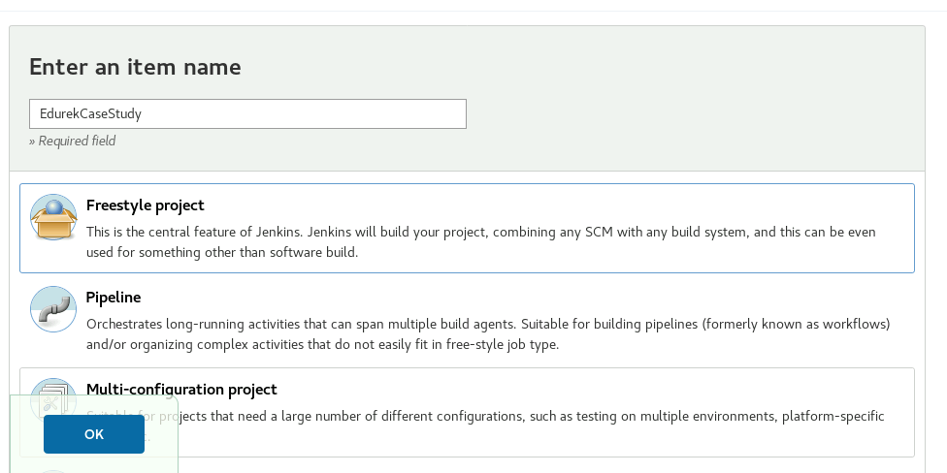

2.Enable “Git” in Source Code Management and Provide the repository

URL as :https://github.com/debasis567/jenkins-demo.git

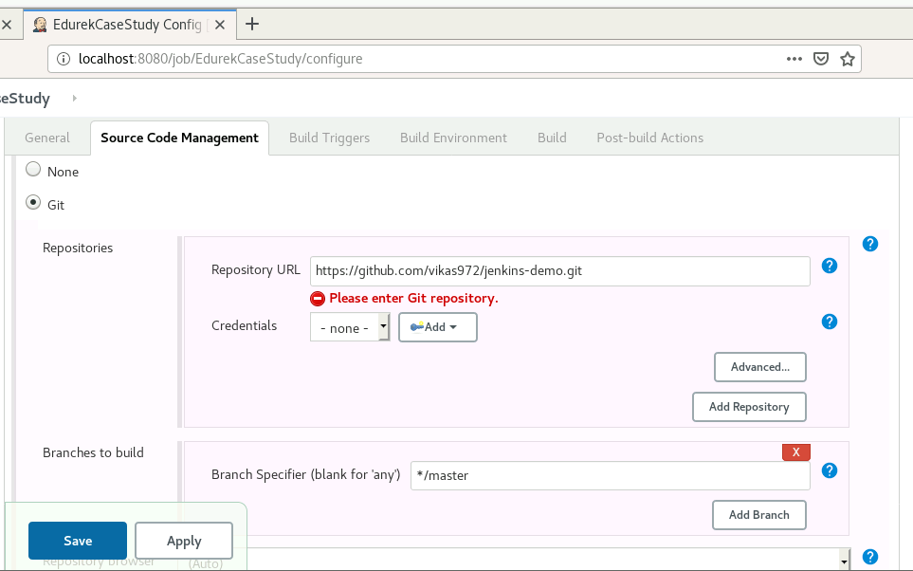

3.Enable Poll SCM and update the schedule in it.

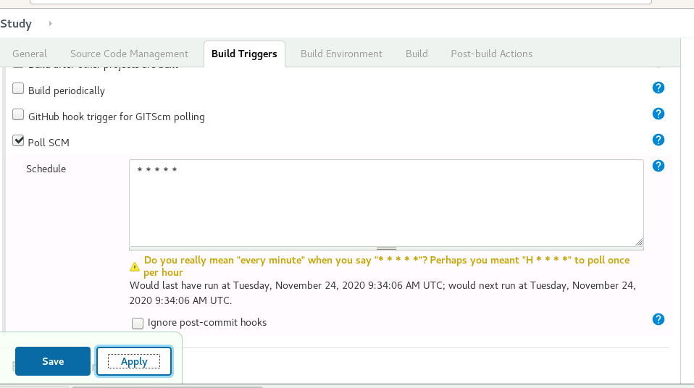

4.Enable the Build Environment to “Delete workspace before build starts” and “ Abort the build if it's stuck”.

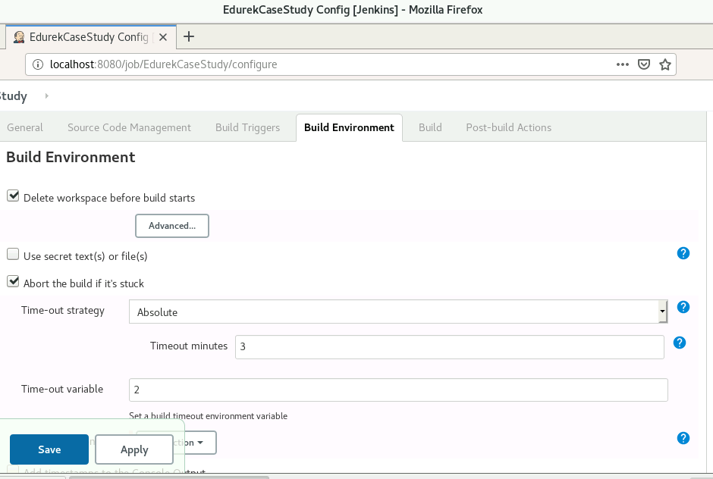

5.In Build select “Execute shell”, give permission to the shell script to be executed (chmod +x Fibonacci.sh), add the shell script to be

executed and redirect the output of the shell script to a file in workspace (${WORKSPACE}/Fibonacci.sh 5 > output.txt).

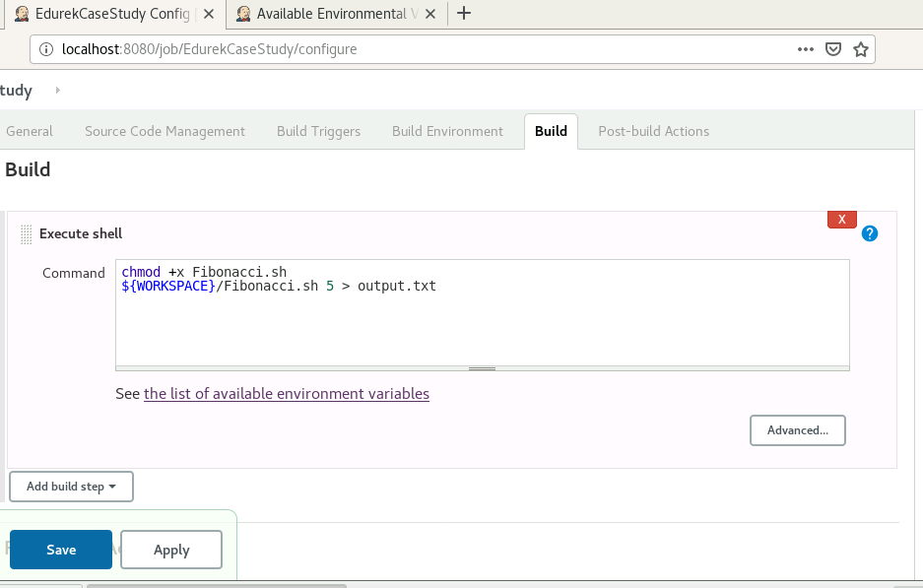

6.Apply and save the job

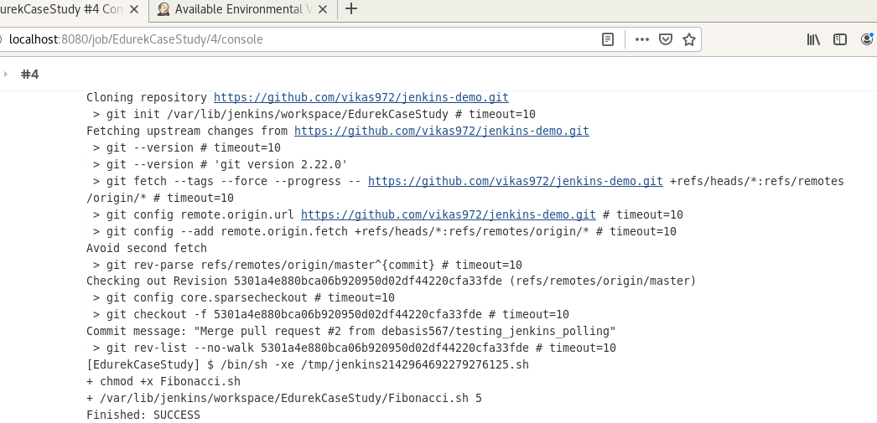

7.Upon triggering the job, the execution has to be success and the output file containing the shell script output should be present in Workspace.

